This report explores and looks at the relationship between different demographic variables and survey responses that were collected from past semesters. Some key questions that were explored include the influence of the time of day, student type (depending on what year they are and if they are graduate students or not), and the respondents’ religious background and beliefs and political leaning on their responses. Interesting findings are ones that indicate that a certain demographic factor has a significant impact and effect on how the respondents answer specific questions. To see if there was any significant impact, there must be a statistically significant relationship between the demographic variables and how the respondents answered the questions. Therefore, using statistical methods, such as Chi-square tests for independence and different correlations functions, this analysis identifies the factors that have significant differences in response patterns.

This dataset contains responses to a survey, which included different background questions about demographic factors. The key demographics that were explored were which year of school they were in, how old they were, if they had any religious background and how spiritual they were, which gender they are, and it also looked at how their parents lean in political beliefs, and also how the respondents themselves lean in their political beliefs. Each response also included a timestamp at which the survey was completed and submitted, which allowed for some analysis based on time of day when the survey was completed. All the questions on the survey required them to read a scenario of a person responding to a certain situation, then after seeing the results of those actions, the respondents would decide if that person in the scenario was either ‘Not a jerk’, ‘Mildly a jerk’, or ‘Strongly a jerk’. Given the different demographics, the goal of this analysis is to see if there are any statistically significant effects on how different factors could influence the survey responses.

In addition, the raw survey data given was also messy and incomplete, which required some clean up before being able to do any statistical analysis on it. The first step taken to clean this dataset was by dropping any duplicate values. Even with every demographic question and survey responses being the same, the probability of being submitted at the exact same time was very small, and the resulting code also showed that there were no rows dropped for duplicate values, therefore, no duplicates were seen. There were many cells that were missing data for both demographics background questions and survey responses. To handle the missing survey responses, the empty cells were replaced with the mode of the answers in that column. In the case of missing demographic background answers, if all of them were missing, that row was removed because there would be no way to test how the demographics of that person would affect their survey responses without any demographic information. The other data cleaning was to match their age to which year they were, which was done by getting the median of that year’s age and filling the missing values in. After the data cleaning, most, if not all, of the missing cells were filled and now was a complete dataset with no missing values and anomalies

The main question that was the focus of this analysis was whether or not there is a significant association between political leaning and how spiritually strong, or not spiritually strong at all, they are and how they answered the survey questions. Based on past experiences and even the political climate now, there is at least some correlation between how spiritual a person is and which way they lean on a political scale. Therefore this analysis is testing if there really is a statistically significant impact between spirituality and political leaning.

To test whether or not there is a significant impact between these two variables, the dataset was first split by how strong a person’s religiousness or spirituality was. It was split by these three categories: “Strongly spiritual”, “Somewhat spiritual”, and “Not spiritual at all”. Once the data set was split, the Chi-square tests were done on each of these datasets. The first category that was given to the Chi-square test was how they would describe themselves on a political scale: “Strongly Liberal”, “Mildly Liberal”, “Neutral”, “Mildly Conservative”, “Strongly Conservative”, and “Don’t know / It’s complicated”. The second categorical variable were the survey questions that each of the respondents had to answer.

With these two variables, the first Chi-square test was conducted to see if there was any influence that political belief was associated with how strongly spiritual respondents answered a particular question. With each question’s P-value being greater than alpha(0.05), it was found that there was no statistical significance that there was any influence of how spiritual they were and their political leaning to determine the outcome of the questions. The second Chi-square test was conducted to see if there was a significant influence that political belief was associated with how the somewhat spiritual group answered, and similarly the third Chi-square test was conducted with the not spiritual group. The results for the second test showed that there was one question that had a statistically significant influence. For the third test, there were three questions that had a statistically significant influence of how the non-spiritual group was impacted by their political belief.

In addition to these tests, bar charts were created to see the distribution of the answers and where they lie in terms of political sides. These charts show that for the “Not Spiritual” chart, the ‘Not Jerk’ dominates all political leaning, with most on the liberal side. In the “Somewhat Spiritual” chart, it also follows a similar pattern to the “Not Spiritual” chart, but there is an increase in ‘Mild Jerk’ responses. However in the “Strongly Spiritual” there is a more even spread of answers across the political groups, and majority of these people are within the

middle range of political leaning from ‘Mild Liberal’ to ‘Mild Conservative’. Also it is important to note that the number of people in the “Strongly Spiritual” chart is much lower than in the other two charts, which could have had an effect on the Chi-square tests.

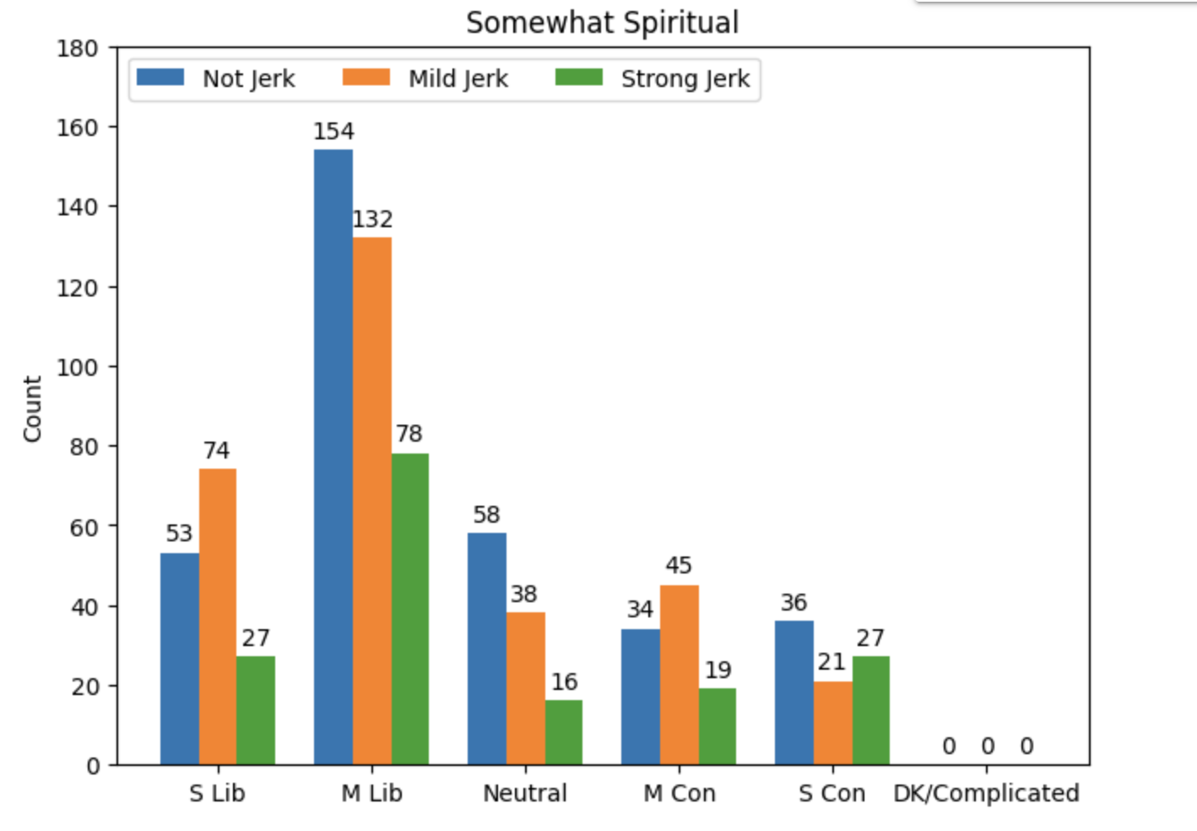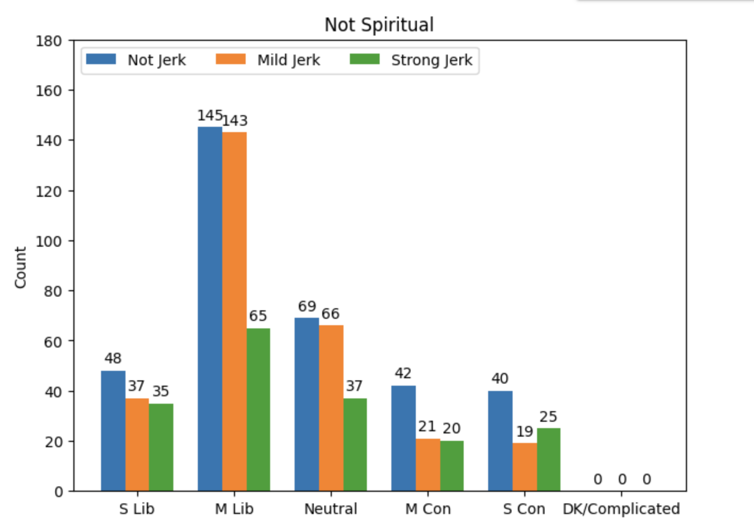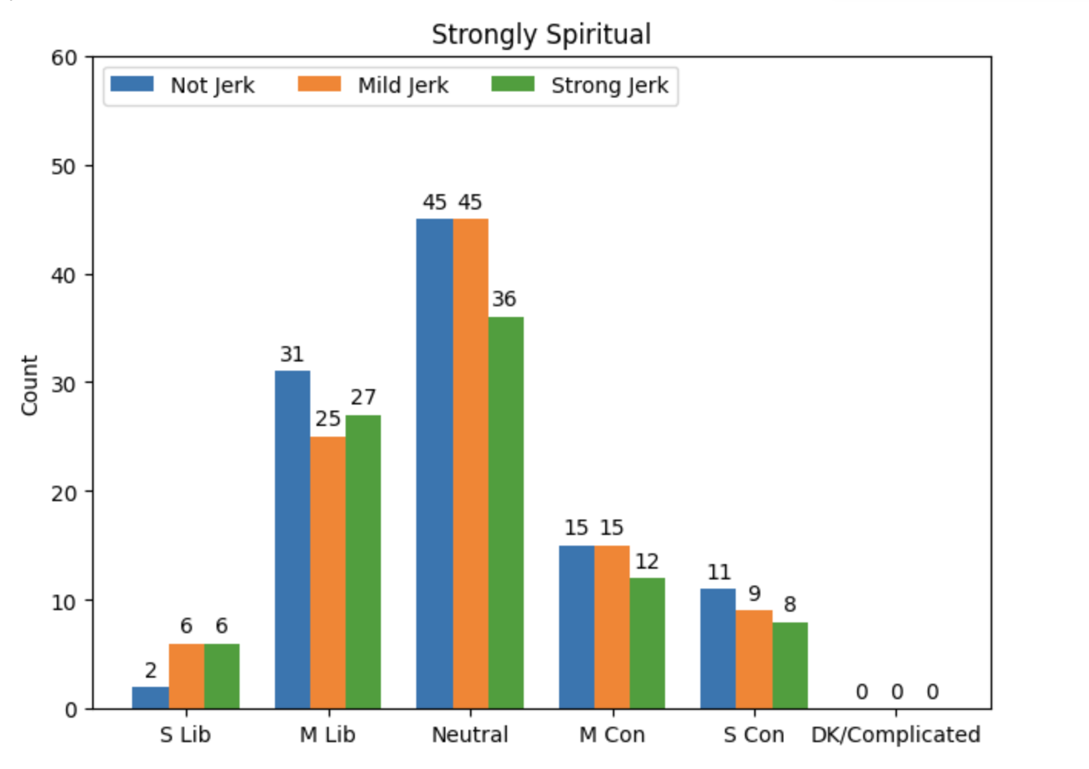These results from the Chi-square tests for independence and bar charts were not that surprising because in general, people who are religious and have some practice in spirituality will most likely follow that religion’s moral laws and guidelines. Therefore, those with strong spirituality or at least some, will not be affected by their political leaning, but rather follow their religion’s set of laws and apply it to these scenarios. On the other hand, those who do not follow a religion or practice a spirituality, they have their own morals, but it is not set in stone as some religions. Therefore those who do not follow a religion or practice spirituality will more likely be impacted by their political beliefs and apply to these scenarios and answer them. So, given the charts and Chi-square tests, in conclusion, if a person is more strongly spiritual there is little to no statistically significant impact of political leaning on how they will answer questions, and vice versa, if a person is less spiritual or don’t practice it at all, there is statistically significant impact of political leaning on how they will answer questions.